Gowtham Subramanian  
Michael Gildein  
Web Technologies  
MSIS_517L  
February 21, 2017

Development Assignment 1

**Design of my Webpage:**

index.html is the main page which contains Home, About, Skills, Contact Information, Experience tabs and a button to download the Resume.

Styles and image:

* Included a picture on the Home page.
* Used different font size, italics, strong, bold, regular for fonts in different pages
* Tried various colors with white background
* Used Footer to include copyright information

**Code Validation:**

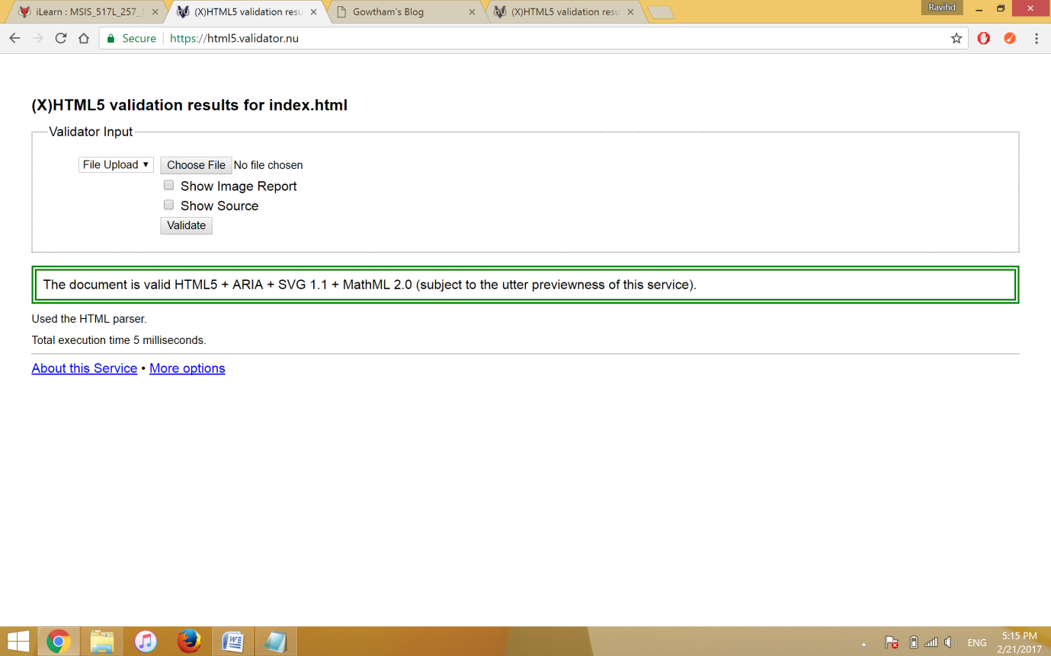

**Code Validation:**

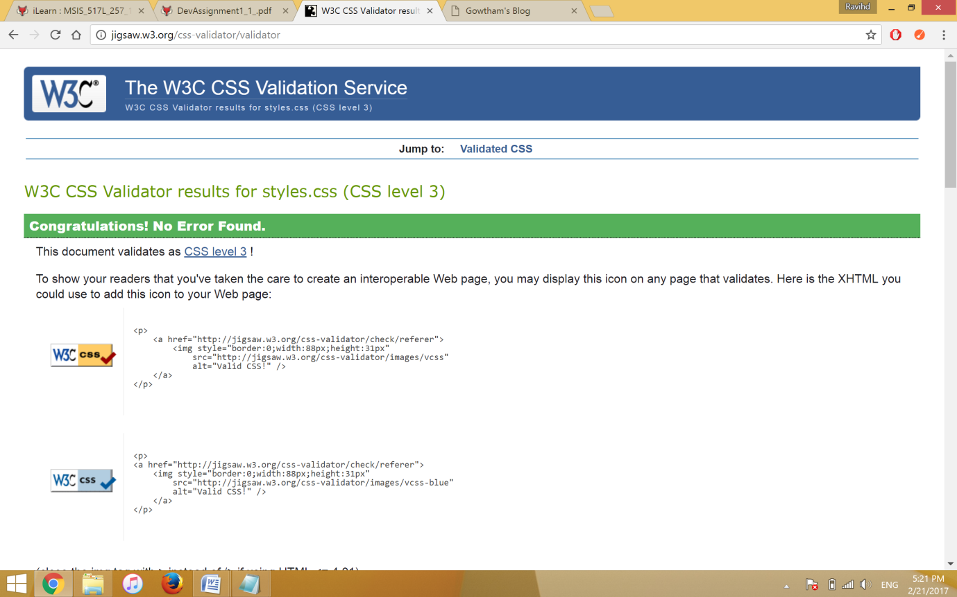

**Link to GitHub Repository:**

https://github.com/ShreshtaR/DevelopmentProject1.git